**Full Stack Development with MERN**

**Project Documentation**

**1. Introduction**

**Project Title:** Online Learning Platform Using MERN

* **Team Members:** Jocelyn M

Sharmila V

Sheeba C

Ambigai J

Divya Sree D

**2. Project Overview**

* **Purpose:** Accessibility: To provide learners with access to educational resources and courses from anywhere in the world, breaking geographical barriers.  
  Interactivity: To facilitate engaging and interactive learning experiences through multimedia content, quizzes, and forums.  
  Personalization: To allow learners to tailor their educational journeys based on their interests, pace, and learning styles.
* **Features:** An online learning platform using the MERN stack (MongoDB, Express.js, React, Node.js) should feature user authentication and role-based access for students and instructors. It must include course management tools, enabling instructors to create and manage courses, while providing students with a searchable course catalog and enrollment options. The platform should support various content types, including video lectures and interactive quizzes, along with discussion forums for community engagement. Additionally, it should incorporate progress tracking, analytics, and payment integration for course purchases. Finally, a responsive design and admin dashboard are essential for managing users and content effectively.

**3. Architecture**

* **Frontend:** The front end of an online learning platform built with the MERN stack utilizes React to create a dynamic and responsive user interface that enhances the learning experience. Users can easily navigate through a visually appealing course catalog, where they can filter and search for courses based on their interests. Interactive components allow students to engage with multimedia content, participate in quizzes, and join discussion forums for real-time collaboration. A personalized dashboard provides students with insights into their progress, upcoming assignments, and course recommendations. The platform also ensures accessibility and mobile-friendliness, allowing users to learn anytime and anywhere.
* **Backend:** The backend architecture of an online learning platform using the MERN stack (MongoDB, Express.js, React, Node.js) is structured to efficiently handle user interactions and data management. It employs Node.js as the server runtime and Express.js to create RESTful API endpoints for user authentication, course management, enrollment, and progress tracking. MongoDB serves as the database, storing data such as user profiles, course details, and progress records in a flexible, document-oriented format. Middleware is utilized for authentication, error handling, and logging, while a service layer encapsulates the business logic for various operations. Additionally, the architecture may incorporate cloud storage for media files, real-time features for user engagement, and security measures to protect data integrity, all while ensuring scalability and ease of deployment.
* **Database:** The database schema for an online learning platform consists of several key collections, including Users, Courses, Modules, Progress Tracking, and Reviews. The Users collection stores user information such as name, email, password hash, role, and enrolled courses. The Courses collection contains details about each course, including the title, description, and associated instructor. Modules are linked to courses and include content, quizzes, and other educational materials. The Progress Tracking collection monitors user progress within courses, recording completed modules and scores. Reviews and Ratings allow users to provide feedback on courses, including comments and star ratings. Interactions with MongoDB involve CRUD operations, indexing for performance, and referencing to maintain relationships between collections.

**4. Setup Instructions**

* **Prerequisites:** Express.js

Mongoose

bcryptjs

jsonwebtoken

cors

dotenv

multer

express-validator

* **Installation: Step 1: Clone the Repository**

Open your terminal.

Navigate to the desired directory

Clone The Repository

Navigate the Clone Repository

**Step 2: Install Dependencies**

Navigate to the server directory

Install server – side dependencies

Navigate to the client directory

**Step 3: Set up Environmental Variables**

Install Client – side dependencies

Create a .env file in the server directory

Open the .env file and all the necessary variables

**Step 4: Start The application**

Start the server

Open a new terminal window or tab

Navigate to the client directory

Start the client

**Step 5 : Access the client**

Open the web browser and go to

<https://localhost:3000>

**5. Folder Structure**

* **Client:** The structure of a React frontend for an online learning platform using the MERN stack typically includes a main App.js file that orchestrates the routing and layout of the application. Components are organized into directories such as components for reusable UI elements, pages for different views like course listings and user profiles, and hooks for custom hooks that manage state and side effects. A context or redux folder may be included for global state management, allowing for seamless data sharing across components, such as user authentication and course progress. The assets directory contains stylesheets, images, and other static files, while a utils folder may house helper functions for API calls and data formatting. Overall, this structure promotes modularity, maintainability, and scalability, essential for a dynamic online learning platform.
* **Server:** The organization of a Node.js backend for an online learning platform using the MERN stack typically follows a modular architecture, with a clear separation of concerns. The main entry point is often an index.js or server.js file that initializes the Express server and connects to the MongoDB database. The backend is structured into directories such as routes for defining API endpoints, controllers for handling the business logic, and models for defining the data schema using Mongoose. Middleware functions, such as authentication and error handling, are organized in a middleware directory to ensure clean and reusable code. Additionally, configuration files for environment variables and database connections are usually stored in a config folder, promoting a scalable and maintainable codebase.

**6. Running the Application**

* Provide commands to start the frontend and backend servers locally.
  + **Frontend:** cd path/to/your/online-learning-platform/client

npm start

* + **Backend:** cd path/to/your/online-learning-platform/server

npm start

**7. API Documentation**

The Node.js backend for an online learning platform using the MERN stack exposes several key endpoints to manage users, courses, enrollments, and reviews. Users can register with a POST request api/users/register, providing their username, email, and password, and log in via api/users/login to receive a JWT token. The user profile can be accessed with a GET request to api/users/profiles, requiring the token for authentication, and updated with a PUT request to the same endpoint. Course management includes creating a new course with a POST request to api/courses retrieving all courses with a GET request to /api/courses, and accessing specific course details via api/courses/:id Instructors can update or delete courses using PUT and DELETE requests to api/courses/:id mid, respectively.

**8. Authentication**

In an online learning platform using the MERN stack, authentication is typically handled through JSON Web Tokens (JWT). When a user registers or logs in, the server validates their credentials and generates a JWT, which is then sent back to the client for storage, usually in local storage or cookies. For subsequent requests to protected routes, the client includes the JWT in the Authorization header, allowing the server to verify the token's validity and extract user information. Authorization is enforced by middleware functions that check the user's role and permissions before granting access to specific resources, such as course creation or profile updates. This layered approach ensures that only authenticated users can access certain features, while also allowing for role-based access control to manage different user capabilities effectively

**9. User Interface**

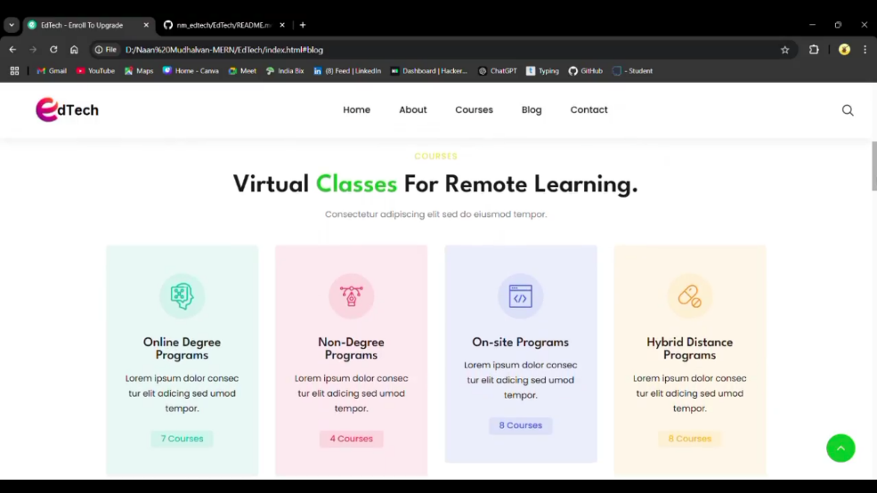

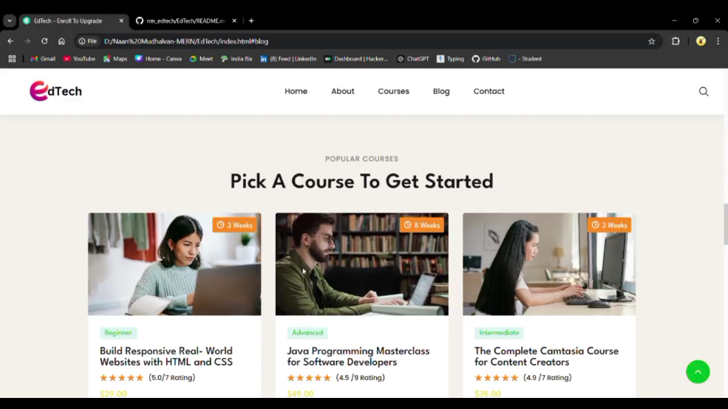

**10. Testing**

In an online learning platform built with the MERN stack, a comprehensive testing strategy is crucial for ensuring reliability and user satisfaction. The strategy begins with **unit testing,** which focuses on testing individual components or functions in isolation, such as React components and backend API endpoints. Next**, integration testing** is employed to verify that different modules or services interact correctly, ensuring seamless communication between the frontend and backend**. End-to-end (E2E) testing** simulates real user scenarios, validating the entire application flow from the user interface to the backend, ensuring all parts work together as intended.

**Performance testing** assesses the application's responsiveness and stability under various load conditions, helping to identify potential bottlenecks. **User Acceptance Testing (UAT)** involves actual users testing the application to ensure it meets their needs, providing valuable feedback for final adjustments. Tools like **Jest** and Enzyme are commonly used for unit testing React components, while Mocha  and **Chai** are popular for backend testing in Node.js applications. For API testing, SuperTest allows developers to make HTTP requests and assert responses effectively. Cypress is utilized for end-to-end testing, simulating user interactions in the browser, while Postman  and its command-line companion Newman facilitate automated API testing. Finally ,Lighthouse is employed for performance audits, ensuring the application adheres to best practices for speed and accessibility. This multi-faceted approach to testing helps maintain high-quality code and a seamless user experience.

**11. Screenshots**

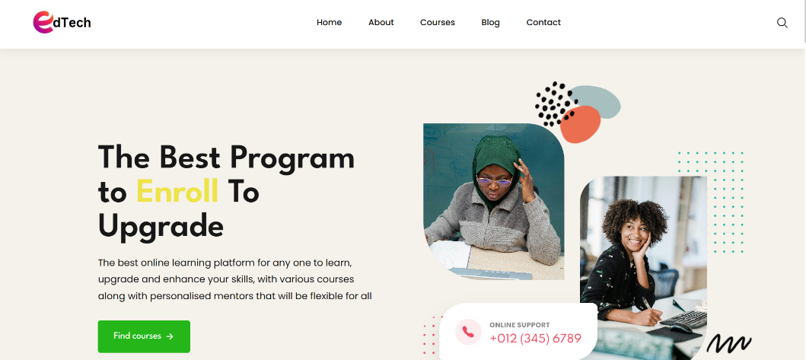

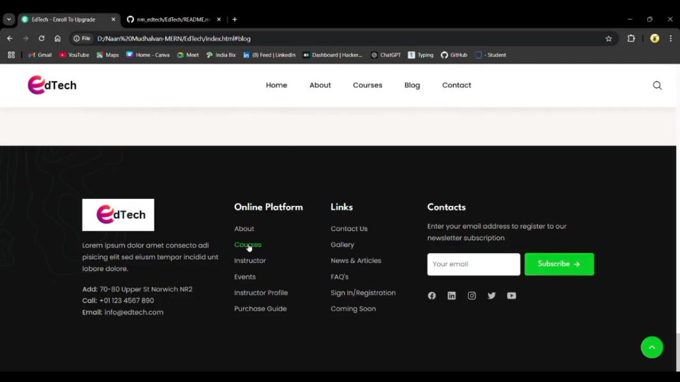

**12. Known Issues:**

Online learning platforms built with the MERN stack may face several known issues that can impact user experience and functionality. One common issue is scalability, where the platform may struggle to handle a large number of concurrent users, leading to slow response times or crashes during peak usage. Data synchronization can also be problematic, especially when multiple users are accessing or modifying shared resources, which may result in inconsistencies or data loss. Additionally, security vulnerabilities such as inadequate authentication and authorization mechanisms can expose sensitive user information and lead to unauthorized access. Finally, cross-browser compatibility issues may arise, where the platform does not function consistently across different web browsers, affecting accessibility for users.

**13. Future Enhancements**

Future features and improvements for online learning platforms using the MERN stack could focus on enhancing user engagement and learning outcomes. Implement real-time collaboration tools would allow students to work together seamlessly, fostering a more interactive learning environment. Personalized learning experiences through AI-driven recommendations can help tailor content to individual student needs, improving retention and understanding. Additionally, integrating gamification elements such as badges, leader boards, and rewards can motivate learners and make the educational process more enjoyable. Enhancements in security measures, including advanced encryption and multi-factor authentication, will ensure user data protection and build trust in the platform. Finally, incorporating **mobile responsiveness** and Progressive Web App (PWA) features will allow users to access learning materials anytime, anywhere, thus increasing accessibility and convenience.